Install Chef server on Amazon EC2 Ubuntu 14.04

The **Chef server** is the hub of interaction between all **workstations** and **nodes** using Chef. Changes made through workstations are uploaded to the Chef server, which is then accessed by the chef-client and used to configure each individual node.

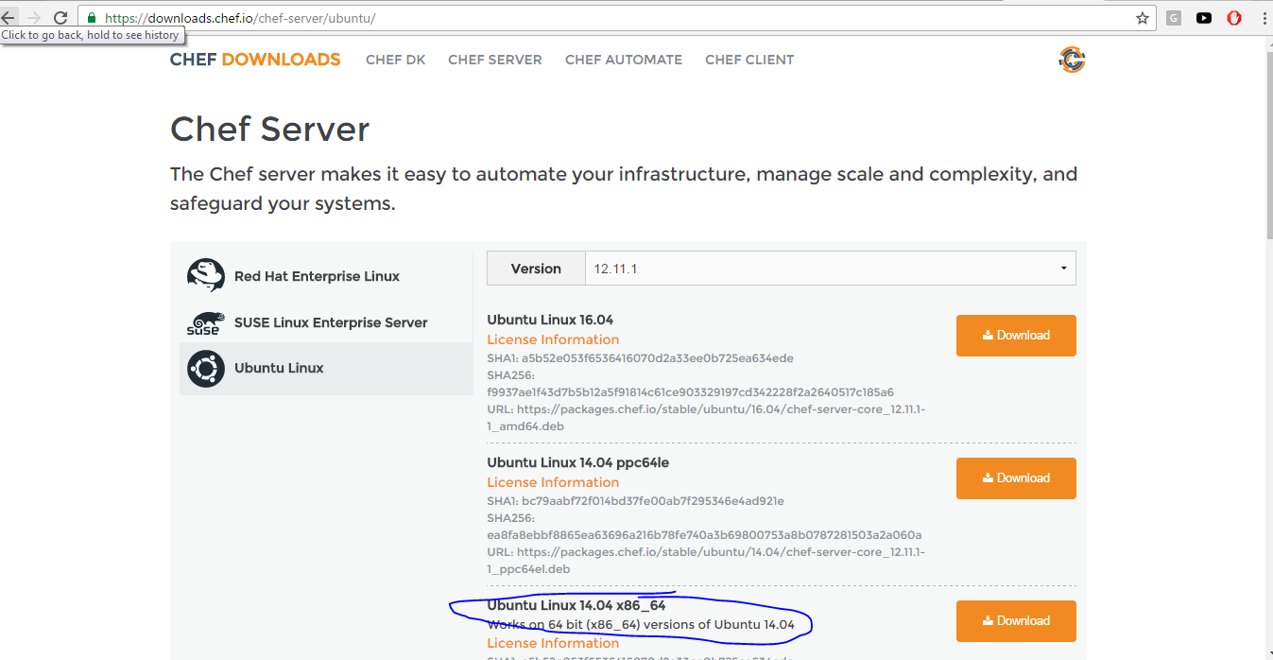

ubuntu@ip-172-31-10-101:~$ wget https://packages.chef.io/stable/ubuntu/14.04/chef-server-core_12.11.1-1_amd64.deb

Install the Chef server:

1. ubuntu@ip-172.31.10.101:~$ sudo dpkg -i chef-server*

This will install the base Chef 12 system onto the server.

1. Once the installation is complete, we should run chef-server-ctl reconfigure command to start the Chef server services. It configures the components that make up the server to work together in our specific environment:
2. ubuntu@ip-172.31.10.101:~$ sudo chef-server-ctl reconfigure
3. ...
4. Chef Server Reconfigured!

Once the installation is complete, you must call the command, which configures the components that make up the server to work together in your specific environment:

1. ubuntu@ip-172.31.10.101:~$ sudo chef-server-ctl status
2. run: bookshelf: (pid 4486) 39s; run: log: (pid 4526) 39s
3. run: nginx: (pid 4269) 44s; run: log: (pid 4679) 35s
4. run: oc_bifrost: (pid 4199) 46s; run: log: (pid 4246) 45s
5. run: oc_id: (pid 4253) 45s; run: log: (pid 4258) 44s
6. run: opscode-erchef: (pid 4591) 36s; run: log: (pid 4580) 38s
7. run: opscode-expander: (pid 4367) 41s; run: log: (pid 4469) 40s
8. run: opscode-expander-reindexer: (pid 4435) 40s; run: log: (pid 4475) 40s
9. run: opscode-solr4: (pid 4308) 42s; run: log: (pid 4344) 42s
10. run: postgresql: (pid 4151) 46s; run: log: (pid 4174) 46s
11. run: rabbitmq: (pid 1685) 136s; run: log: (pid 4138) 47s
12. run: redis_lb: (pid 4086) 64s; run: log: (pid 4673) 35s
13. ubuntu@ip-172.31.10.101:~$ sudo chef-server-ctl test

The Chef core server is now installed and started. The next steps is to configure it to allow us to log in.

Create a default user and organization

The next step is to create a default user and organization for the chef-server.

Next, we need to create an admin user. This will be the username that will have access to make changes to the infrastructure components in the organization we will be creating.

We can do this using the **user-create** subcommand of the **chef-server-ctl** command. The command requires a number of fields to be passed in during the creation process.

We will create a user with the following information:

1. Username: admin
2. First Name: admin
3. Last Name: admin
4. Email: admin@testorg.com
5. Password: password
6. Filename: admin.pem

Also, we will create an organization with the following information:

1. Short Name: testorg
2. Long Name: testorg.com
3. Association User: admin
4. Filename: testorg.pem
5. In order to link workstations and nodes to the Chef server, an administrator and an organization need to be created with associated RSA private keys. From the home directory, create a **.chef** directory to store the keys:
6. ubuntu@ip-172-31-10-101:~$ mkdir .chef
7. Let's create an administrator:
8. ubuntu@ip-172-31-10-101:~$ sudo chef-server-ctl user-create admin admin admin admin@testorg.com password -f ~/.chef/admin.pem
9. We should now have a private key called **admin.pem** in **~/.chef/** directory.

1. Create an organization with the **org-create** subcommand:
2. ubuntu@ip-172-31-10-101:~$ sudo chef-server-ctl org-create testorg "testorg.com" --association_user admin -f ~/.chef/testorg.pem

Now, we should have two .pem key files in **~/.chef/** directory:

ubuntu@ip-172-31-10-101:~/.chef$ ls

admin.pem testorg.pem

We will need to connect to this server and download these keys to our workstation momentarily. For now though, our Chef server installation is complete.

Opscode Manage (GUI)

Let's install the GUI plugin for the Chef:

ubuntu@ip-172-31-10-101:~$ sudo chef-server-ctl install opscode-manage

ubuntu@ip-172-31-10-101:~$ sudo opscode-manage-ctl reconfigure

ubuntu@ip-172-31-10-101:~$ sudo chef-server-ctl reconfigure

We can access the web interface by typing **https://domain** from our browser. Because the SSL certificate is signed by an authority not recognized by our browser, we may get a warning. Click on the "Proceed anyway" button.

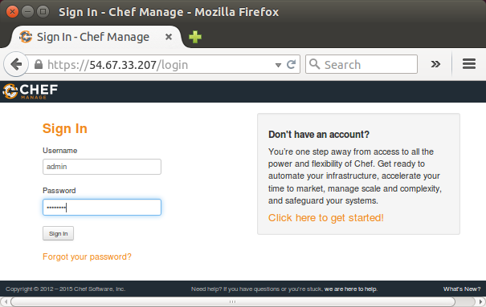

After login with **admin** credentials we setup earlier, we get "Chef Manage" page:

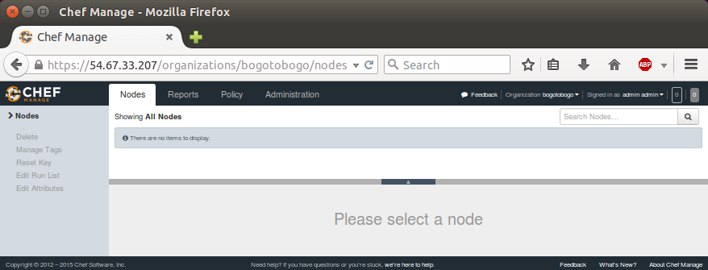

At this point, we do not have anything to display!

Other Chef plugins

There are other useful plugins:

**Opscode Push Jobs plugin**

1. $ sudo chef-server-ctl install opscode-push-jobs-server
2. $ sudo opscode-push-jobs-server-ctl reconfigure
3. $ sudo chef-server-ctl reconfigure

**Analytics plugin**

1. $ sudo chef-server-ctl install opscode-analytics
2. $ echo 'analytics_fqdn "FQDN"' | sudo tee -a /etc/opscode-analytics/opscode-analytics.rb
3. $ sudo opscode-analytics-ctl reconfigure
4. $ sudo chef-server-ctl reconfigure